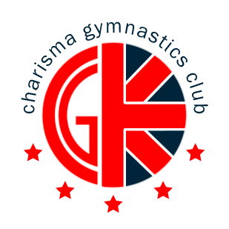
October half-term Camp 2017
We are pleased to be able to offer various gymnastics classes over October half term.
Come along and join in the fun in a safe, happy environment, with experienced qualified coaches. CLASSES ARE FOR AGE 4 UPWARDS
If you would like your son/daughter to attend, please return the booking slip attached with the appropriate fee by: SATURDAY 21st October 2017
For further enquiries contact: charismacamps@outlook.com

DATES OF COURSE: Monday 23rd October – Friday 27th October 2017
1/ Ages 4-5
Morning - 2 HOURS (9-11am)
1 DAY £20.00
2 DAYS £38.00
3 DAYS £54.00
4 DAYS £68.00
5 DAYS £80.00

2/ Ages 6 and Over
Morning – 3 HOURS (9am-12pm) Afternoon - 3 HOURS(1- 4pm)
1 DAY £30.00 1 DAYS £30.00
2 DAYS £54.00 2 DAYS £54.00
3 DAYS £77.00 3 DAYS £77.00
4 DAYS £96.00 4 DAYS £96.00
5 DAYS £112.00 5 DAYS £112.00
For gymnasts aged 6 and over the sessions can be booked as single sessions or combined:
Morning + Afternoon on the SAME day
1 Complete Day £55.00
2 Complete Days £100.00
3 Complete Days £140.00
4 Complete Days £175.00
5 Complete Days £200.00

Please ensure your gymnast has adequate drink and food for their time at the club.
Charisma is a nut free environment due to allergies!





CHARISMA GYMNASTICS CAMPS
Booking conditions:
1. Refunds can only be made at the discretion of the senior coach. If cancellation is due to the child sickness, a request for a refund must be made in writing, accompanied by a doctor’s certificate
2. A minimum number of bookings are required to run each activity. In the event of cancellation by CGC customers will be refunded.
3. CGC reserves the right to amend activities without notice.
4. CGC can not be held responsible for any loss or damage to property.
5. Participants should be fit to undertake the gymnastics activity booked. All medication should be handed to the Coach in Charge on arrival.

Please detach and hand in the section below with your payment
I would like to attend Charisma`s Extra gymnastics classes on the following dates and times:
Please tick appropriate boxes.

4-5 Age Group
Date | 9-11am
Monday 23rd October
Tuesday 24th October
Wednesday 25th October
Thursday 26th October
Friday 27th October

6 and Over Age Group
Date | 9-12am | 1-4pm | All Day
Monday 23rd October
Tuesday 24th October
Wednesday 25th October
Thursday 26th October
Friday 27th October

Total Payable = ………….
Payment must be attached with booking form in order to secure a place
Bank details: Charisma Gym Club, Sort code: 20-05-57 Account No: 83165582

Name Of Child ……………………………………………………………Child's Age……………..

Contact Number during class times: 1……………………………………………………………….

2……………………………………………………………….

Please list any medical conditions or any medication being taken

……………………………………………………………………………..

Signed …………………………………………….. Print Name ………………………………….

Date …………………………………………………

Photographs may be taken during the camp, if you do NOT want your child to be in the pictures please indicate below;

I do NOT wish my child to be in any Camp pictures, Signed………………………………………………………….

