E: [guy.thompson@ntlworld.com-](mailto:guy.thompson@ntlworld.com-) W: www.charismagymnastics.co.uk - F: [www.facebook.com/CharismaGC--](http://www.facebook.com/CharismaGC--)

Charisma Gymnastic Club’s Summer Newsletter 2017

## http://www.charismagymnastics.co.uk/wp-content/uploads/2014/10/LOGO.pngUpcoming Events

**June 10th &11th**

Level 5+ Team competition at Heathrow Gymnastics Club

**June 24th**

Charisma General Gymnasts **Parent open day** – Book an appointment with Gina if you have any concerns or questions (not compulsory)

**June 25th**

Level 4+ @ Heathrow Gymnastics Club

**July 2nd**

Charisma BBQ and Presentation day! (Look out for tickets soon!)

**July 8th-9th**

2nd Bi-Annual Charisma Competition

**July 22nd**

Last day of Gym

**August 31st**

Return to Gym

**September 24th**

Level 4+ Competition @ Heathrow G.C

**October 15th**

Level 5 Competition @ Heathrow G.C

**October 8th**

Level 4+ Competition @ Heathrow G.C

**12th November**

Teddy Twin Competition @ Heathrow G.C

|  |
| --- |
|  |
|  |

**Charisma BBQ is returning!**

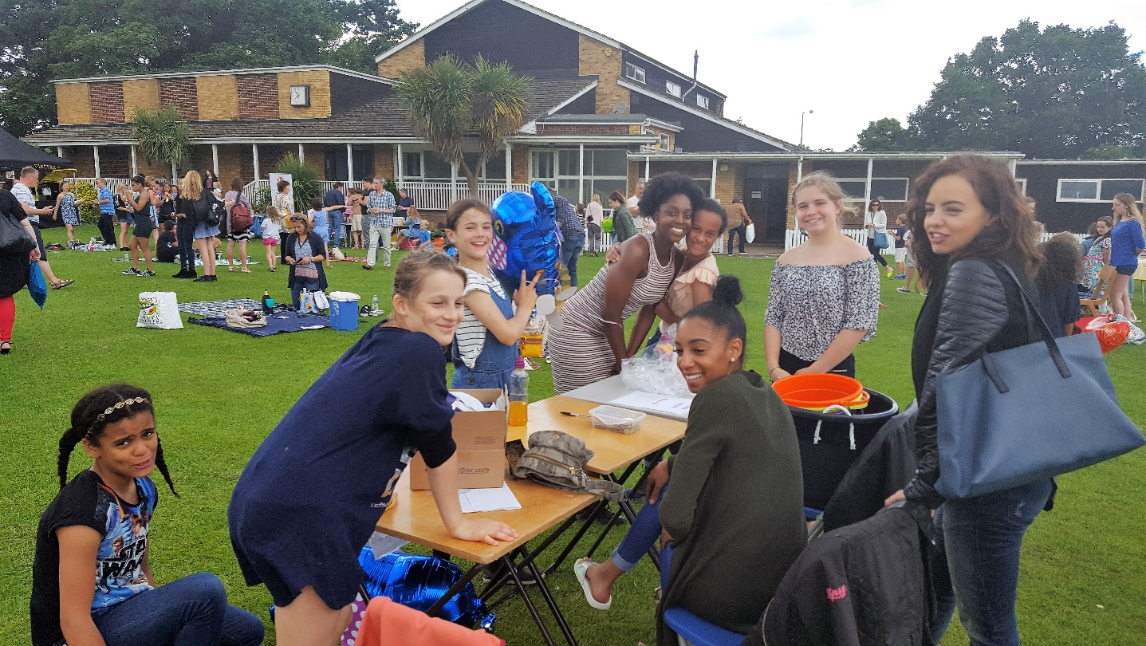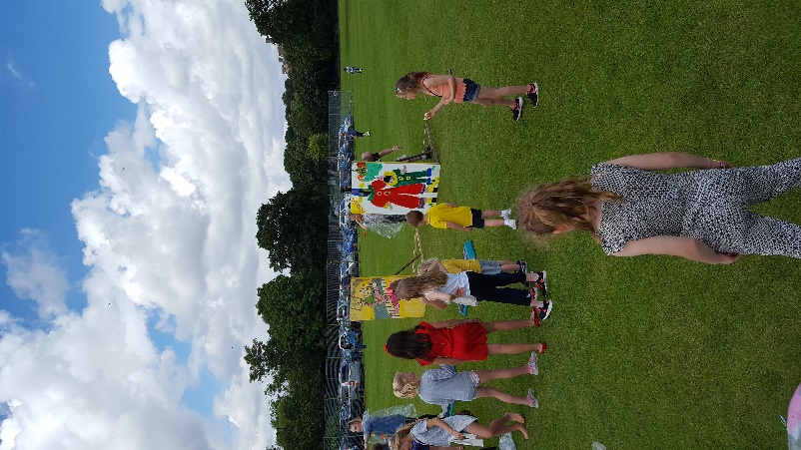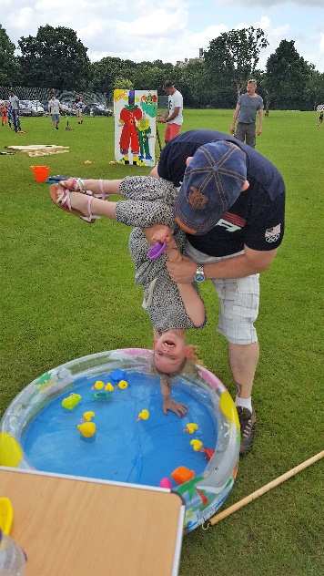After the success of 2016’s Charisma Fundraiser and Awards Presentation we are pleased to inform you that this fantastic event will be returning on

**July 2nd, 2017.**

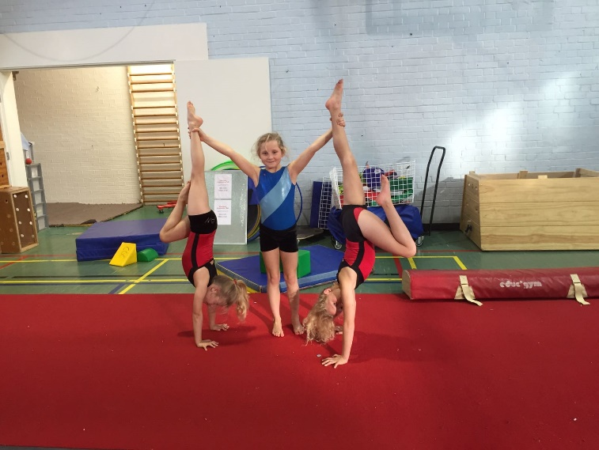The favourite Stalls from last year will be returning! Including the Vietnamese burger van, hook a duck, hair styling, cocktails, nail painting, Face painting, sponge a Coach, Cake decorating, Sweets and much more going on outside! The presentation will take place inside, where your gymnasts could win Gymnast of the Year, Most improved amongst many more awards! This is a huge event for us to celebrate a fantastic year at Charisma. Make Sure you get your tickets now! Your family and friends are most welcome to come along and celebrate!

## Charisma “Gym Camp” Classes- August 2017

Gym Camps are for **ALL** gymnasts to come and have fun, whilst learning gymnastics and to keep training during their school holidays. We welcome all levels of ability and will ensure those from our beginners to our squad gymnasts enjoy their time. There will be displays, games, challenges and the gymnasts will get to work on their skills, technique and fitness! Make sure you sign up quickly as spaces are provided on a first come basis.

**We will be running our next Camp from 21/08/2017-25/08/2017**

Please send all Camp related enquiries to: [**charismacamps@outlook.com**](mailto:charismacamps@outlook.com)

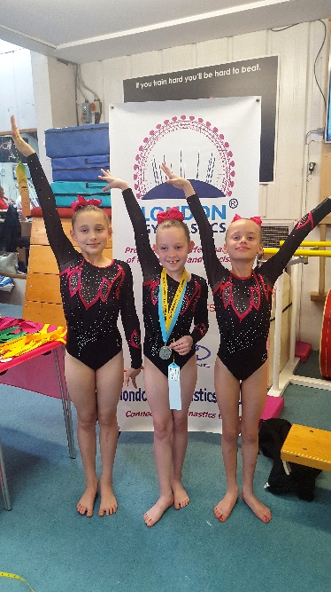 **Level 5 Competition on May 7th**

|  |
| --- |
| Charisma Competition On **Saturday 8th and Sunday 9th** July, we’re holding our second bi-annual competition.  We need **volunteers** to help on the day with everything from making cakes, running the Café helping to set up equipment. If you feel you can help in any way please let us know, it would be much appreciated!    **Exam Desks**  Urgent help needed! It is the time of year when we must put away (and put out) over 200 desks and chairs due to exams taking place in the college. Any parent that can be available to help on a Friday evening from at 5.15 and 3.00pm on a Saturday it would be greatly appreciated. If you are in the gym watching from the balcony we would appreciate you coming to help with the desks (or equipment if you are feeling strong)  **We Are a Nut Free Zone!**  No nuts in snack/lunch boxes, please help protect our gymnasts who are allergic to nuts and nut products!  **Lost and Found**  We have a buildup of lost property that has not been collected for months. If you have lost something, please come and see if we have it or we will be sending it off to Charity.  **Drop off and Collection**  All children under 11 years should be accompanied by an adult through the turnstiles into the gym. Please make sure the gymnasts are safely on the warm up area before leaving. Children under 11 years will not be allowed to leave the gym unattended. Secondary school children may be unaccompanied upon travelling to and from the gym if they have written consent confirming this arrangement from a parent. |
|  |

Phenomenal results at the Regional Level 5! It all began with Olivia, Lyla, Holly, Rocsi, and Tilly who produced some beautiful performances. Lyla standing out on floor and winning her first regional gold, a phenomenal silver on Vault and a 5th place ribbon! Olivia also performed brilliantly finishing with a 6th place ribbon and a huge smile! Rocsi, Tilly and Holly also performed wonderfully at their first ever Heathrow Competition.

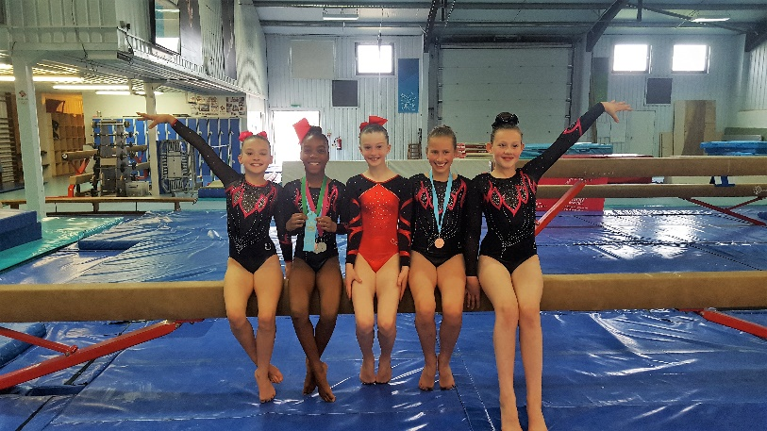In the next round Parker, Cameron, Madeleine, Veronica and Amelie performed and made everyone extremely proud. Cameron winning silver medals on Bars and Vault with a brilliant Bronze on Beam and a 5th place standing. Whilst Veronica shared the Podium with Cameron with a fabulous bronze on Vault.

Our Seniors showed their experience also earning medals; Millie and Phoenix shared silver on vault with Millie also obtaining an impressive 4th place ribbon. Livia showed her grace with a fantastic bronze on Beam. Hazel finished the day for us with brilliant performances amongst tough competition. Overall the girls really were **#Charismagic** showing us brilliant attitudes and performances against the best clubs in London. Well done girls!

**Smarties Fundraising**

A massive thank you to everyone who took part in fundraising activities over the past year. With our annual smarties fundraiser, you have managed to raise **£2000.40** This is our best smarties result!

We have set up a Crowd Funding Campaign for our Sprung Floor which we would love to have prior to our competition. Please share it on Facebook and donate where you can! [www.justgiving.com/crowdfunding/CharismaGymnasticsClub](http://www.justgiving.com/crowdfunding/CharismaGymnasticsClub) community. A Sprung Floor and improvements to our equipment really benefits our gymnasts experience and we really need the Charisma community to pull together in order to make this happen!

**Preschool Time Changes**

**Head Girls**



Well done to Helena Heyndrickx and Evelyn Bonner who have been doing a fantastic job of Head Girl and Assistant Head Girl. The girls were awarded these titles/responsibilities at the Charisma Presentation BBQ. Helena and Evelyn have been with the club for over 10 years now, and are now both fantastic Regional Gymnasts. Soon they will hand over the reins to the next Head Girls.

Thank you for all your hard work girls!

|  |
| --- |
|  |
| **Feedback Forms**  The club is always looking at ways to improve, if you have any ideas or comments please complete a feedback form, available at the front desk. We welcome all comments both positive and negative.  **Welfare Officer**  If you have any safeguarding concerns, you can contact our Welfare Officers on 0208 462 8004. Please see our website for further information.  *Our coaches always have up to date Safeguarding certificates.*  **Gym Mark Club**  Image result for gym mark club  We are very proud to be one of the first clubs in 2003 to attain this prestigious Award. We have been officially recognized as a safe friendly and effective environment for children continuously since 2003. |

Please be aware that from September there will be some changes to our Preschool times. This will ensure a smoother changeover between dismissal and arrival of the next class. **FROM SEPTEMBER 2nd 2017**

* The 10.45-11.30am Class will run from 11.00-11.45
* The 11.30-12.30 Class will run from 11.45-12.45.

**Renewal of membership!**

The Autumn term fee and annual membership are now due You will shortly be advised by email of the cost. Please pay promptly by Bank transfer to avoid the queues. There is a card machine available however there will be a £1.50 Bank charge for cheques. Please inform us as soon as possible at [guy.thompson@ntlworld.com](mailto:guy.thompson@ntlworld.com) if you do not wish to retain your place.

**Waiting List**

We still have a huge waiting list. If you know someone who is interested in joining Charisma, please see the following page on the Charisma Website: [www.charismagymnastics.co.uk/want-to-join](http://www.charismagymnastics.co.uk/want-to-join)

**Important Reminders**

* Please use the **changing rooms** provided even if you are running late.
* Please do not block the corridor, this is a Health and Safety concern
* Please ensure you have and are using your ID Cards
* Never enter the gym during training sessions as it can be dangerous and distracting for the gymnasts.
* Mobile phones are not permitted in viewing areas.
* If you wish to use your phone when waiting for your child, please go to our cafeteria
* Parents should only video their gymnasts at competition.
* Please keep us up to date with your records including medical information, care plans, and contact details.

**Congratulations to our fantastic coaches!**

Many congratulations to **Hannah Edwards** and **Stephanie Paez** who have recently passed their Floor and Vault judging course!

**Finally, …**

Thanks to our superb onesie fundraising effort we now have adopted our very own Giraffe, look out for our special picture of Charisma and our adoption certificate in the gym. Thank you for supporting the Giraffe Conservation Foundation!