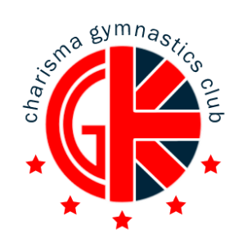

Charisma Camps February 2018
Valentines theme
“I Love Gymnastics” Week! 12th-16th February
We are pleased to be able to offer various gymnastics classes over the February half term.
Come along and join in the fun in a safe, happy environment, with experienced qualified coaches.
CLASSES ARE FOR AGE 4 UPWARDS
If you would like your son/daughter to attend, please return the booking slip attached with the appropriate fee by:
Saturday 9th February 2018
For further enquiries contact: charismacamps@outlook.com
Payment information- By card, cash or Bank Transfer
To Charisma GC :
Sort code: 20-05-57 Account Number: 83165582
Booking Conditions:
- Refunds can only be made at the discretion of the senior coach. If cancellation is due to the child sickness, a request for a refund must be made in writing, accompanied by a doctor’s certificate.
- A minimum number of bookings are required to run each activity. In the event of cancellation by CGC customers will be refunded.
- CGC reserves the right to amend activities without notice.
- CGC cannot be held responsible for any loss or damage to property.
- Participants should be fit to undertake the gymnastics activity booked. All medication should be handed to the Coach in Charge on arrival.
- Please detach and hand in the booking form with your payment
- Gymnasts must have adequate food (lunch and snacks if staying all day), A water bottle and a tracksuit for warmth throughout the day
Please note:
- For squad gymnasts attending a daytime camps session on the same day as the evening squad sessions; a squad discount of £10 will be provided, so long as the booking has been made prior to the deadline stated above.

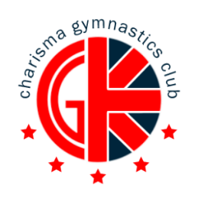

February Camps Form
Please complete each section:
Date | Preschool  4-5yrs  09:00-11:00 | General  6+yrs  09:00-12:00 | General  6+yrs  13:00-16:00 | General  6+yrs  09:00-16:00 | Squad Only Evening Session  16:30-19:30  Mon-Weds | Squad add on 16:30-18:30 Thurs/Fri
Monday 23rd October
Tuesday 24th October
Wednesday 25th October
Thursday 26th October
Friday 27th October

Payment

2 hours  Preschool/Squad add on session | 3 hours  Morning/Afternoon/Squad Evening | All day
1 DAY: £20.00 | 1 DAY: £30.00 | 1 DAY: £55.00
2 DAYS: £38.00 | 2 DAYS: £54.00 | 2 DAYS: £100.00
3 DAYS : £54.00 | 3 DAYS : £77.00 | 3 DAYS : £140.00
4 DAYS : £68.00 | 4 DAYS : £96.00 | 4 DAYS : £175.00
5 DAYS: £80.00 | 5 DAYS: £112.00 | 5 DAYS: £200.00

Total Paid _______________

Child’s Full Name: | Child’s Age:
Contact Number #1: | Contact Number #2:
Medical Conditions: | Medications:
Signed: | Date:

Photographs and video footage may be taken during camps. Please indicate below and sign if you do NOT wish your child to be in such photos

