May 2016 Charisma Bulletin
Charisma Gymnastic Club
Upcoming Events

May 31st –June 3rd

½ term Classes!
July 2nd
Founders day- Morning Classes as Normal, finish at 12:30. Off-site games will be organized for afternoon classes should they wish to attend.
July 3rd
Charisma Presentation BBQ

July 9th-July 10th
Charisma Bi-Annual Comp
Sat 23rd July
Last sessions before Summer Break!

Thu 1st September
First sessions back!

Christmas
We Break up on 17th December, we will return in the New Year on 5th January.

3rd December
Charisma Roller Disco! Following the success of 2015!

Club of the Year 2011!
- www.facebook.com/groups/CharismaPV
- www.charismagymnastics.co.uk
- T: +44 (0)208 462 8004 E: guy.thompson@ntlworld.com
Hello Everyone,
Welcome back to all our members and a massive welcome to those who have just joined Charisma, we hope your time at Charisma GC will be long and happy. If you have any concerns regarding your child`s gymnastics please speak to Gina.
We hope your gymnasts are enjoying their time with us! Please continue reading for the most up to date information you may need to know about Charisma!

Charisma ½ Term Classes

You may notice a few changes at the next half term course. We are introducing a Preschool group from 9-11am. We will be running General Classes throughout the week from 9-12am and 1-4pm. Squad and advanced gymnasts are welcome throughout the week as we will cater for all levels and abilities. This being said, squad specific groups will only be available on Thursday 2nd and Friday 3rd. Please sign up to secure your place as soon as possible! It will be a fun-filled week full of all apparatus, acrobatics and displays! We hope to see you there!
Smarties Tubes and Fundraising
Thank you to everyone taking part in fundraising activities over the past year. Over the coming months we will increase our levels of fundraising. We need to replace matting and hope to get new equipment such as a sprung floor area. Therefore; please keep a look out on our fundraising activities and get involved with the Charisma community, as it will really benefit your child’s gymnastics experience and we really need your help! Recently we held our smarties tube fundraising challenge. The winners will be announced very soon. Please bring back your smarties tubes to help the club and to be in with a chance of winning a floor session with Catherine Lyons (Britain`s First Junior European Gold Medalist on Floor)!
Keep a look out for more information on Facebook!
www.facebook.com/groups/CharismaPV

Renewal of membership!

Reminders

Charisma Competition
On Saturday 9th and Sunday 10th July, we’re holding our second bi-annual competition. We would like as many children as possible to take part in this friendly competition. So please do not forget to bring your entry forms back. The closing date will be May 14th.
We also need volunteers to help on the day with everything from making cakes, running the Café helping to set up equipment. If you feel you can help in any way please let us know, it would be much appreciated!
Exam Desks
Urgent help needed! It is coming to the time of year when we have to put away and put out over 200 desks and chairs due to exams taking place in the college. Any parent that can be available to help on a Friday evening at 5.00 and 3.00pm on a Saturday it would be greatly appreciated. Start date Friday 6th May 2016.
We Are a Nut Free Zone!
No nuts in snack/lunch boxes, please help protect our gymnasts who are allergic to nuts and nut products!

Charisma Leotard and Attire
It would be nice if as many Gymnasts as possible were wearing the Charisma leotard at the competition, please speak to Karen or Mary if you wish to order one. Last order date before the competition:
14th May 2016

T- Shirts and bags are also available.

The Autumn term fee and annual membership is due in the beginning of June. You will be advised by email at the beginning of June how much this will be.
Prompt payment is essential to secure a place. If you do not want your place after the summer please inform us as soon as possible in writing by email to guy.thompson@ntlworld.com We still have hundreds of children and counting on the waiting list, Thank you!
Membership cards
Thank you for working with us to ensure every member has an ID Card and is using it.
Changing Rooms
Children must not change in the corridor! All parents are to ensure they use the changing rooms provided even if you are running late and the class has already started. The club would be very grateful if parents could abide by the rules as we are constantly being told by the college about this!
Safety in the Gym
Parents should not enter the gym EVER during training sessions as it can be dangerous and distracting for the gymnasts. All parents are welcome to watch from the viewing gallery.
Another issue is the misuse of mobile phones. In response to this British Gymnastics recommends that mobile phones should not be used in viewing areas. If you wish to use your phone while watching your child, please come down from the viewing gallery to the cafeteria/ front desk.
Keeping records up to date
Please keep us up to date with any changes of address or phone numbers, school and medical information. All parents signing up in September will be asked to check their child’s details on the database with Karen. It is necessary to keep all our health and safety records up to date for membership and insurance purposes.
GymMark Club
We were one of the first clubs in 2003 to attain this prestigious Award when it was introduced and we are very proud of this fact. This means we are recognized as a safe friendly and effective environment for your child.
Drop off and Collection
Good Luck to Catherine Lyons
Notice her first Charisma Medals on the cushion.
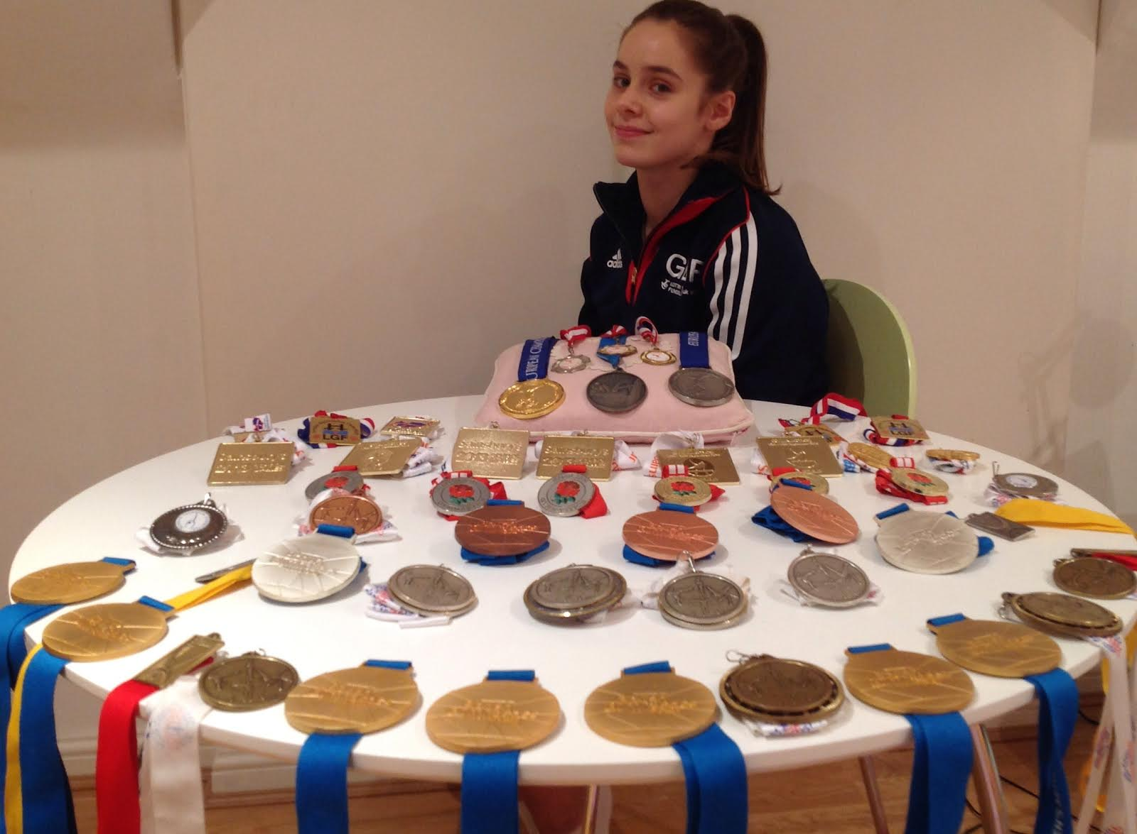
In 2014 Catherine became All Round Junior Women’s Artistic Gymnastics Champion. Catherine also Won, Vault, Beam and Floor Titles, and was crowned British Silver Medalist on the Bars.
Catherine is taking part in the final trial for a place at the Rio Olympics in June 2016, we wish her all the best and hope her Olympic dreams come true.
Keep an eye out for her she will be returning to the club to help with some floor work and show off all her amazing medals and maybe sign a few autographs.
Head Girls
Well done to Megan Parsons and Lauren Rousseau-Charles who have been doing a fantastic job of Head Girl and Assistant Head Girl. Megan and Lauren have been with the club for over 10 years now, and are now both Level 4 – Regional Gymnasts.

All children who are of primary school age should be accompanied by an adult through the turnstiles into the gym. Please make sure the gymnasts are safely on the warm up area before leaving the gym. Likewise, primary school age children need to be collected from inside the gym and will not be allowed to leave the gym unattended. Secondary school children may come to gym unaccompanied as long as they written consent confirming you are happy for your child to travel to and from the gym.
Welfare Officer
Part of our Gym Mark requirement is that we should have a welfare officer. We have 3 appointed welfare officers. Details are found on our notice board and website. If you have any safeguarding concerns, you can contact them on 0208 462 8004.
All our coaches regularly update their Safeguarding and Protecting Children Certificate.
Parents Open Day for General Gymnasts
We will be holding an open day on Sat 16th July 2016. This day is designed like a parents evening at school where you can speak to Gina about your child’s Progress. Please register your interest with Gina as soon as possible to make an appointment. It is not compulsory only if you have questions or concerns.
Competitions
Throughout the year gymnasts are invited to attend competitions. Parents are asked to confirm your child’s entry and send payment before the entries close as we are unable to guarantee late entries. Late entries of up to one week may be considered but will receive an inconvenience charge. To prevent disappointment please ensure you are aware of your child’s upcoming competitions and when you need to enter by.
Waiting List
We still have a huge waiting list. If you know someone who is interested in joining Charisma, please don’t bring them along with your child as this can cause great disappointment. All new members will need to be put on a waiting list. Please see the following page on the Charisma Website: www.charismagymnastics.co.uk/want-to-join
Feedback Forms
The club is always looking at ways to improve, if you have any ideas or comments please complete a feedback form, available at the front desk. We welcome all comments both positive and negative.

